Relation Negation Operators : != OR <> (NOT EQUAL TO)

Not in

Not between

Reverse of special operators and relational operators is called negation operators.

Logical operators.

7654 MARTIN SALESMAN 7698 28-SEP-81 1250 1400

30

7844 TURNER SALESMAN 7698 08-SEP-81 1500 0

30

7876 ADAMS CLERK 7788 23-MAY-87 1100

20

7900 JAMES CLERK 7698 03-DEC-81 950

30

7934 MILLER CLERK 7782 23-JAN-82 1300

10

111 SUR_ESH

15 rows selected.

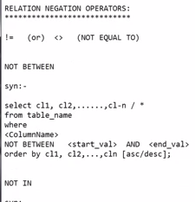

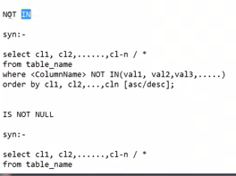

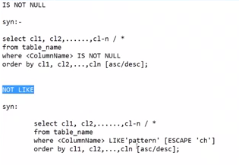

SQL> -- GET EMPS WITH COMMISSION

SQL> SELECT * FROM EMP WHERE COMM IS NOT NULL;

EMPNO ENAME JOB MGR HIREDATE SAL COMM

---------- ---------- --------- ---------- --------- ---------- ----------

DEPTNO

----------

7499 ALLEN SALESMAN 7698 20-FEB-81 1600 300

30

7521 WARD SALESMAN 7698 22-FEB-81 1250 500

30

7654 MARTIN SALESMAN 7698 28-SEP-81 1250 1400

30

7844 TURNER SALESMAN 7698 08-SEP-81 1500 0

30

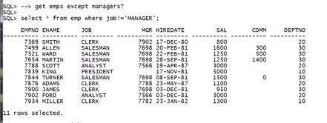

SQL> SELECT * FROM EMP WHERE JOB != 'MANAGER';

EMPNO ENAME JOB MGR HIREDATE SAL COMM

---------- ---------- --------- ---------- --------- ---------- ----------

DEPTNO

----------

7839 KING PRESIDENT 17-NOV-81 5000

10

7788 SCOTT ANALYST 7566 19-APR-87 3000

20

7902 FORD ANALYST 7566 03-DEC-81 3000

20

7369 SMITH CLERK 7902 17-DEC-80 800

20

7499 ALLEN SALESMAN 7698 20-FEB-81 1600 300

30

7521 WARD SALESMAN 7698 22-FEB-81 1250 500

30

7654 MARTIN SALESMAN 7698 28-SEP-81 1250 1400

30

7844 TURNER SALESMAN 7698 08-SEP-81 1500 0

30

7876 ADAMS CLERK 7788 23-MAY-87 1100

20

7900 JAMES CLERK 7698 03-DEC-81 950

30

7934 MILLER CLERK 7782 23-JAN-82 1300

10

11 rows selected.

SQL> SELECT * FROM EMP WHERE JOB <> 'MANAGER';

EMPNO ENAME JOB MGR HIREDATE SAL COMM

---------- ---------- --------- ---------- --------- ---------- ----------

DEPTNO

----------

7839 KING PRESIDENT 17-NOV-81 5000

10

7788 SCOTT ANALYST 7566 19-APR-87 3000

20

7902 FORD ANALYST 7566 03-DEC-81 3000

20

7369 SMITH CLERK 7902 17-DEC-80 800

20

7499 ALLEN SALESMAN 7698 20-FEB-81 1600 300

30

7521 WARD SALESMAN 7698 22-FEB-81 1250 500

30

7654 MARTIN SALESMAN 7698 28-SEP-81 1250 1400

30

7844 TURNER SALESMAN 7698 08-SEP-81 1500 0

30

7876 ADAMS CLERK 7788 23-MAY-87 1100

20

7900 JAMES CLERK 7698 03-DEC-81 950

30

7934 MILLER CLERK 7782 23-JAN-82 1300

10

11 rows selected.

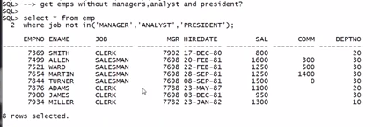

SQL> SELECT * FROM EMP WHERE JOB NOT IN (MANAGER, ANALYST, PRESIDENT);

SELECT * FROM EMP WHERE JOB NOT IN (MANAGER, ANALYST, PRESIDENT)

*

ERROR at line 1:

ORA-00904: "PRESIDENT": invalid identifier

SQL> SELECT * FROM EMP WHERE JOB NOT IN (MANAGER, ANALYST, PRESIDENT);

SELECT * FROM EMP WHERE JOB NOT IN (MANAGER, ANALYST, PRESIDENT)

*

ERROR at line 1:

ORA-00904: "PRESIDENT": invalid identifier

SQL>

SQL> SELECT * FROM EMP WHERE JOB NOT IN (PRESIDENT, MANAGER, ANALYST);

SELECT * FROM EMP WHERE JOB NOT IN (PRESIDENT, MANAGER, ANALYST)

*

ERROR at line 1:

ORA-00904: "ANALYST": invalid identifier

SQL> SELECT * FROM EMP WHERE JOB NOT IN ('PRESIDENT', 'MANAGER', 'ANALYST');

EMPNO ENAME JOB MGR HIREDATE SAL COMM

---------- ---------- --------- ---------- --------- ---------- ----------

DEPTNO

----------

7369 SMITH CLERK 7902 17-DEC-80 800

20

7499 ALLEN SALESMAN 7698 20-FEB-81 1600 300

30

7521 WARD SALESMAN 7698 22-FEB-81 1250 500

30

7654 MARTIN SALESMAN 7698 28-SEP-81 1250 1400

30

7844 TURNER SALESMAN 7698 08-SEP-81 1500 0

30

7876 ADAMS CLERK 7788 23-MAY-87 1100

20

7900 JAMES CLERK 7698 03-DEC-81 950

30

7934 MILLER CLERK 7782 23-JAN-82 1300

10

8 rows selected.

SQL> SELECT * FROM EMP WHERE JOB NOT IN ('PRESIDENT', 'MANAGER', 'ANALYST', 'CLERK');

EMPNO ENAME JOB MGR HIREDATE SAL COMM

---------- ---------- --------- ---------- --------- ---------- ----------

DEPTNO

----------

7499 ALLEN SALESMAN 7698 20-FEB-81 1600 300

30

7521 WARD SALESMAN 7698 22-FEB-81 1250 500

30

7654 MARTIN SALESMAN 7698 28-SEP-81 1250 1400

30

7844 TURNER SALESMAN 7698 08-SEP-81 1500 0

30

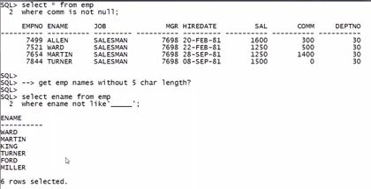

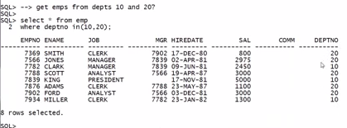

**SQL> -- GET SAL BELOW 1000 AND ABOVE 3000**

**SQL> SELECT * FROM EMP WHERE SAL NOT IN BETWEEN (1000, 3000);**

**SELECT * FROM EMP WHERE SAL NOT IN BETWEEN (1000, 3000)**

**\***

**ERROR at line 1:**

**ORA-00936: missing expression**

**SQL> SELECT * FROM EMP WHERE SAL NOT BETWEEN (1000, 3000);**

**SELECT * FROM EMP WHERE SAL NOT BETWEEN (1000, 3000)**

**\***

**ERROR at line 1:**

**ORA-00907: missing right parenthesis**

**SQL> SELECT * FROM EMP WHERE SAL NOT BETWEEN ('1000', '3000');**

**SELECT * FROM EMP WHERE SAL NOT BETWEEN ('1000', '3000')**

**\***

**ERROR at line 1:**

**ORA-00907: missing right parenthesis**

**SQL> SELECT * FROM EMP WHERE SAL NOT BETWEEN ('1000' '3000');**

**SELECT * FROM EMP WHERE SAL NOT BETWEEN ('1000' '3000')**

**\***

**ERROR at line 1:**

**ORA-00907: missing right parenthesis**

**SQL> SELECT * FROM EMP WHERE SAL NOT BETWEEN ('1000' AND '3000');**

**SELECT * FROM EMP WHERE SAL NOT BETWEEN ('1000' AND '3000')**

**\***

**ERROR at line 1:**

**ORA-00907: missing right parenthesis**

**SQL> SELECT * FROM EMP WHERE SAL NOT BETWEEN 1000 AND 3000;**

**EMPNO ENAME JOB MGR HIREDATE SAL COMM**

**---------- ---------- --------- ---------- --------- ---------- ----------**

**DEPTNO**

**----------**

**7839 KING PRESIDENT 17-NOV-81 5000**

**10**

**7369 SMITH CLERK 7902 17-DEC-80 800**

**20**

**7900 JAMES CLERK 7698 03-DEC-81 950**

**30**

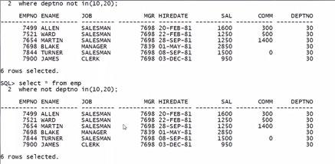

**Logical operators :**

**We can give mul**tiple conditions by using these logical operators in between conditions.

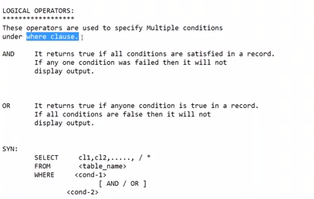

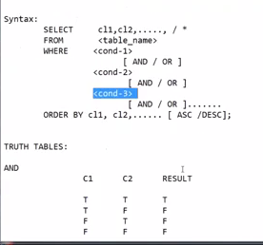

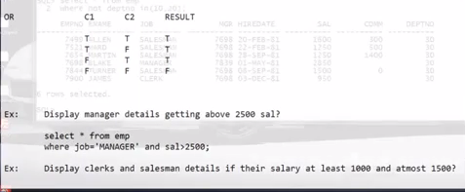

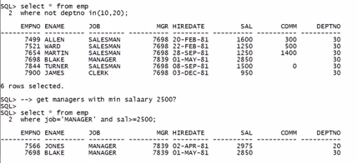

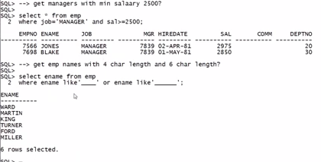

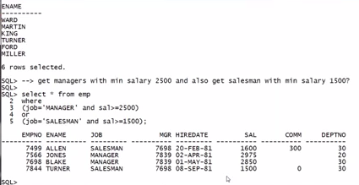

**SQL> -- GET EMP NAMES WITH OUT 5 CHARECTERS LENGTH.**

**SQL> SELECT ENAME FROM EMP WHERE ENAME NOT LIKE '_____';**

**ENAME**

**----------**

**KING**

**FORD**

**WARD**

**MARTIN**

**TURNER**

**MILLER**

**SUR_ESH**

**7 rows selected.**

**SQL> --GET EMPLOYEES WITH JOB NAME BEGINING WITH A**

**SQL> SELECT * FROM EMP WHERE JOB LIKE 'A%';**

**EMPNO ENAME JOB MGR HIREDATE SAL COMM**

**---------- ---------- --------- ---------- --------- ---------- ----------**

**DEPTNO**

**----------**

**7788 SCOTT ANALYST 7566 19-APR-87 3000**

**20**

**7902 FORD ANALYST 7566 03-DEC-81 3000**

**20**

**SQL> ED**

**Wrote file afiedt.buf**

**1* SELECT * FROM EMP WHERE JOB NOT LIKE 'A%'**

**SQL> /**

**EMPNO ENAME JOB MGR HIREDATE SAL COMM**

**---------- ---------- --------- ---------- --------- ---------- ----------**

**DEPTNO**

**----------**

**7839 KING PRESIDENT 17-NOV-81 5000**

**10**

**7698 BLAKE MANAGER 7839 01-MAY-81 2850**

**30**

**7782 CLARK MANAGER 7839 09-JUN-81 2450**

**10**

**7566 JONES MANAGER 7839 02-APR-81 2975**

**20**

**7369 SMITH CLERK 7902 17-DEC-80 800**

**20**

**7499 ALLEN SALESMAN 7698 20-FEB-81 1600 300**

**30**

**7521 WARD SALESMAN 7698 22-FEB-81 1250 500**

**30**

**7654 MARTIN SALESMAN 7698 28-SEP-81 1250 1400**

**30**

**7844 TURNER SALESMAN 7698 08-SEP-81 1500 0**

**30**

**7876 ADAMS CLERK 7788 23-MAY-87 1100**

**20**

**7900 JAMES CLERK 7698 03-DEC-81 950**

**30**

**7934 MILLER CLERK 7782 23-JAN-82 1300**

**10**

**12 rows selected.**

**SQL> SELECT * FROM EMP WHERE JOB LIKE '%MAN%';**

**EMPNO ENAME JOB MGR HIREDATE SAL COMM**

**---------- ---------- --------- ---------- --------- ---------- ----------**

**DEPTNO**

**----------**

**7698 BLAKE MANAGER 7839 01-MAY-81 2850**

**30**

**7782 CLARK MANAGER 7839 09-JUN-81 2450**

**10**

**7566 JONES MANAGER 7839 02-APR-81 2975**

**20**

**7499 ALLEN SALESMAN 7698 20-FEB-81 1600 300**

**30**

**7521 WARD SALESMAN 7698 22-FEB-81 1250 500**

**30**

**7654 MARTIN SALESMAN 7698 28-SEP-81 1250 1400**

**30**

**7844 TURNER SALESMAN 7698 08-SEP-81 1500 0**

**30**

**7 rows selected.**

**SQL> --GET EMPS FROM DEPARTMENTS 10 AND 20**

**SQL> SELECT * FROM EMP;**

**EMPNO ENAME JOB MGR HIREDATE SAL COMM**

**---------- ---------- --------- ---------- --------- ---------- ----------**

**DEPTNO**

**----------**

**7839 KING PRESIDENT 17-NOV-81 5000**

**10**

**7698 BLAKE MANAGER 7839 01-MAY-81 2850**

**30**

**7782 CLARK MANAGER 7839 09-JUN-81 2450**

**10**

**7566 JONES MANAGER 7839 02-APR-81 2975**

**20**

**7788 SCOTT ANALYST 7566 19-APR-87 3000**

**20**

**7902 FORD ANALYST 7566 03-DEC-81 3000**

**20**

**7369 SMITH CLERK 7902 17-DEC-80 800**

**20**

**7499 ALLEN SALESMAN 7698 20-FEB-81 1600 300**

**30**

**7521 WARD SALESMAN 7698 22-FEB-81 1250 500**

**30**

**7654 MARTIN SALESMAN 7698 28-SEP-81 1250 1400**

**30**

**7844 TURNER SALESMAN 7698 08-SEP-81 1500 0**

**30**

**7876 ADAMS CLERK 7788 23-MAY-87 1100**

**20**

**7900 JAMES CLERK 7698 03-DEC-81 950**

**30**

**7934 MILLER CLERK 7782 23-JAN-82 1300**

**10**

**111 SUR_ESH**

**15 rows selected.**

**SQL> SELECT * FROM DEPT;**

**DEPTNO DNAME LOC**

**---------- -------------- -------------**

**10 ACCOUNTING NEW YORK**

**20 RESEARCH DALLAS**

**30 SALES CHICAGO**

**40 OPERATIONS BOSTON**

**SQL> SELECT * FROM DEPT WHERE DEPTNO IN (10,20);**

**DEPTNO DNAME LOC**

**---------- -------------- -------------**

**10 ACCOUNTING NEW YORK**

**20 RESEARCH DALLAS**

**SQL> ED**

**Wrote file afiedt.buf**

**1* SELECT * FROM DEPT WHERE DEPTNO NOT IN (10,20)**

**SQL> /**

**DEPTNO DNAME LOC**

**---------- -------------- -------------**

**30 SALES CHICAGO**

**40 OPERATIONS BOSTON**

**SQL> SELECT * FROM DEPT WHERE NOT DEPTNO IN (10,20);**

**DEPTNO DNAME LOC**

**---------- -------------- -------------**

**30 SALES CHICAGO**

**40 OPERATIONS BOSTON**

**SQL> -- WE CAN GIVE NOT KEYWORD BEFORE OPERATOR OR BEFORE COLUMN NAME**

**SQL> --get managers with minimum salary 2500**

**SQL> select * from emp where ename='manager' and sal>2500;**

**no rows selected**

**SQL> select * from emp where ename='manager' and sal>1000;**

**no rows selected**

**SQL> select * from emp where job='manager' and sal>2500;**

**no rows selected**

**SQL> select * from emp;**

**EMPNO ENAME JOB MGR HIREDATE SAL COMM**

**---------- ---------- --------- ---------- --------- ---------- ----------**

**DEPTNO**

**----------**

**7839 KING PRESIDENT 17-NOV-81 5000**

**10**

**7698 BLAKE MANAGER 7839 01-MAY-81 2850**

**30**

**7782 CLARK MANAGER 7839 09-JUN-81 2450**

**10**

**7566 JONES MANAGER 7839 02-APR-81 2975**

**20**

**7788 SCOTT ANALYST 7566 19-APR-87 3000**

**20**

**7902 FORD ANALYST 7566 03-DEC-81 3000**

**20**

**7369 SMITH CLERK 7902 17-DEC-80 800**

**20**

**7499 ALLEN SALESMAN 7698 20-FEB-81 1600 300**

**30**

**7521 WARD SALESMAN 7698 22-FEB-81 1250 500**

**30**

**7654 MARTIN SALESMAN 7698 28-SEP-81 1250 1400**

**30**

**7844 TURNER SALESMAN 7698 08-SEP-81 1500 0**

**30**

**7876 ADAMS CLERK 7788 23-MAY-87 1100**

**20**

**7900 JAMES CLERK 7698 03-DEC-81 950**

**30**

**7934 MILLER CLERK 7782 23-JAN-82 1300**

**10**

**111 SUR_ESH**

**15 rows selected.**

**SQL> select * from emp where job='MANAGER' and sal>2500;**

**EMPNO ENAME JOB MGR HIREDATE SAL COMM**

**---------- ---------- --------- ---------- --------- ---------- ----------**

**DEPTNO**

**----------**

**7698 BLAKE MANAGER 7839 01-MAY-81 2850**

**30**

**7566 JONES MANAGER 7839 02-APR-81 2975**

**20**

**SQL> --GET EMPLOYEE DETAILS WITH 4 CHAR LENGTH AND 6 CHAR LENGTH.**

**SQL> select * from emp where ENAME LIKE '____' AND '______';**

**select * from emp where ENAME LIKE '____' AND '______'**

**\***

**ERROR at line 1:**

**ORA-00920: invalid relational operator**

**SQL> select * from emp where ENAME LIKE '____' OR '______';**

**select * from emp where ENAME LIKE '____' OR '______'**

**\***

**ERROR at line 1:**

**ORA-00920: invalid relational operator**

**SQL> select * from emp where ENAME LIKE ('____' AND '______');**

**select * from emp where ENAME LIKE ('____' AND '______')**

**\***

**ERROR at line 1:**

**ORA-00907: missing right parenthesis**

**SQL> select * from emp where ENAME LIKE '____' AND ENAME LIKE '______';**

**no rows selected**

**SQL> select * from emp where ENAME LIKE '____' OR ENAME LIKE '______';**

**EMPNO ENAME JOB MGR HIREDATE SAL COMM**

**---------- ---------- --------- ---------- --------- ---------- ----------**

**DEPTNO**

**----------**

**7839 KING PRESIDENT 17-NOV-81 5000**

**10**

**7902 FORD ANALYST 7566 03-DEC-81 3000**

**20**

**7521 WARD SALESMAN 7698 22-FEB-81 1250 500**

**30**

**7654 MARTIN SALESMAN 7698 28-SEP-81 1250 1400**

**30**

**7844 TURNER SALESMAN 7698 08-SEP-81 1500 0**

**30**

**7934 MILLER CLERK 7782 23-JAN-82 1300**

**10**

**6 rows selected.**

**SQL> select * from emp**

**2 WHERE (ENAME='MANAGER' AND SAL>2500)**

**3 OR (ENAME='SALESMAN' AND SAL>1500);**

**no rows selected**

**SQL> WHERE (JOB='MANAGER' AND SAL>2500)**

**SP2-0734: unknown command beginning "WHERE (JOB..." - rest of line ignored.**

**SQL> WHERE (JOB='MANAGER' AND SAL>2500)\**

**SP2-0734: unknown command beginning "WHERE (JOB..." - rest of line ignored.**

**SQL> WHERE (JOB='MANAGER' AND SAL>2500)**

**SP2-0734: unknown command beginning "WHERE (JOB..." - rest of line ignored.**

**SQL> select * from emp**

**2 WHERE (JOB='MANAGER' AND SAL>2500)**

**3 OR (JOB='SALESMAN' AND SAL>1500);**

**EMPNO ENAME JOB MGR HIREDATE SAL COMM**

**---------- ---------- --------- ---------- --------- ---------- ----------**

**DEPTNO**

**----------**

**7698 BLAKE MANAGER 7839 01-MAY-81 2850**

**30**

**7566 JONES MANAGER 7839 02-APR-81 2975**

**20**

**7499 ALLEN SALESMAN 7698 20-FEB-81 1600 300**

**30**

**SQL> SPOOL OFF**